PROJECT 1:

Deploying a web server in Windows instance

Task 1:Create a windows instance using AMI :Windows 2012 R2 baseTask

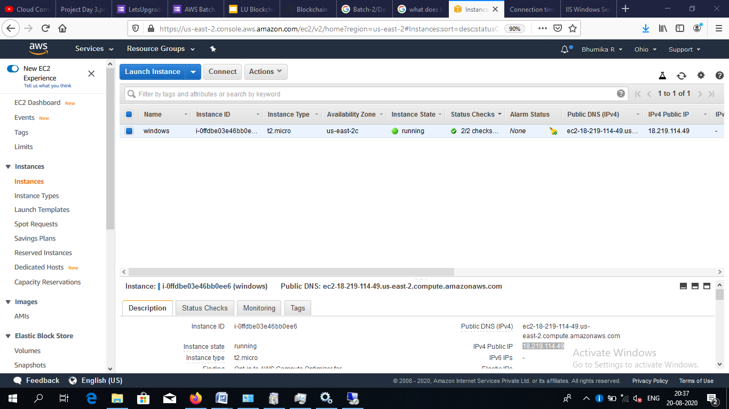

2:Launch the Windows instance using RDPTask

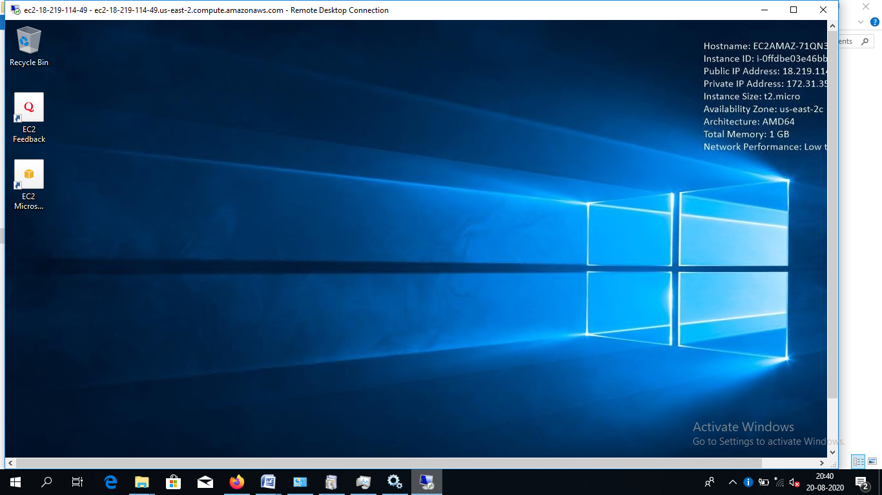

3:Install IIS web server using Powershell ISENote:Simply copy the command below and paste in the powershell ISE to install the IIS web server.!!!!Powershell is case sensitive.Install-WindowsFeature -name Web-Server –IncludeManagementToolsTask

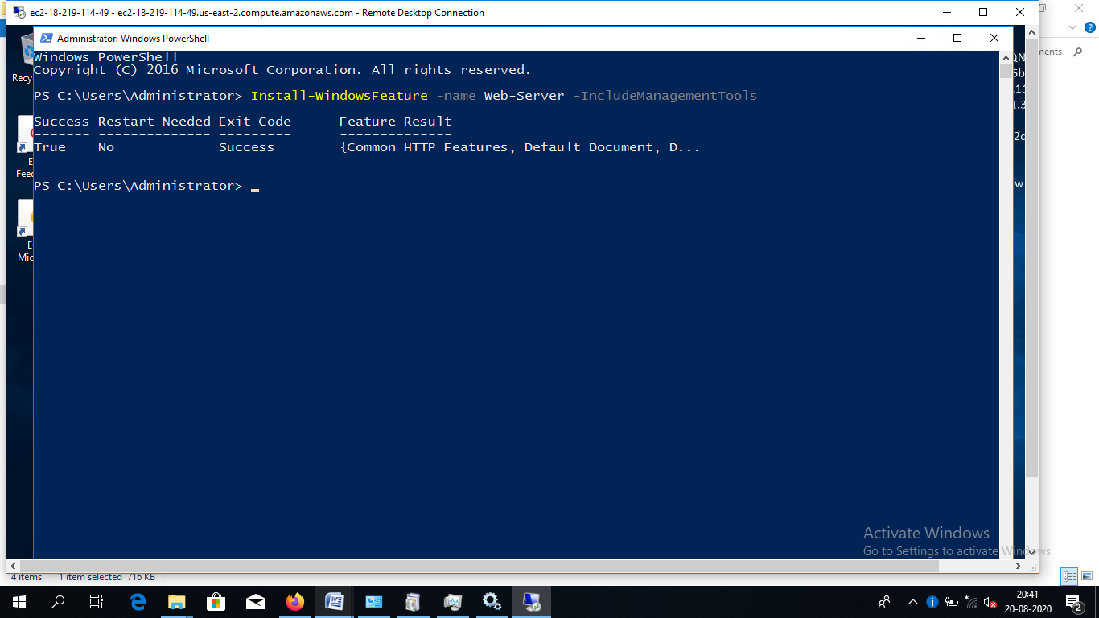

4:Verify successful installation of IIS Web ServerNote :You should be able to see the Internet Information Services Web page when you paste the public IPinto the browser.

